|  |  |
| --- | --- |
|  | Student Name _______________________    **Eastern Goldfields College**  Mathematics Applications U3&4 2018  Test 3 1– Calculator Free Section |
| **Working Time: 30 minutes** | **Total Marks: 31 marks** |

**Question 1 [7 marks: 2, 1, 2, 2]**

A **tree graph** is a planar graph with no cycles. It is an undirected graph in which any two vertices are connected by exactly one path. The following questions all refer to tree graphs.

a) For the following trees state the number of vertices and the number of edges.

i) ii)



Edges = ________________ Edges = ________________

Vertices = ______________ Vertices = ______________

b) Draw a tree with 4 vertices and 3 edges.

c) Is it possible to draw a tree with 4 vertices and 5 edges? Explain your answer.

d) Use the tree in part a) i) above and Euler’s formula to explain why tree graphs are all planar.

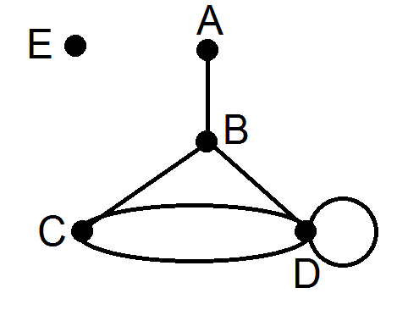**Question 2 [8 marks: 5, 1, 2]**

1. Consider the graph on the right.
   1. Which vertex is adjacent to A? _________
   2. The loop in the graph connects which vertex to itself?   
        
       ___________
   3. Which pair of vertices is connected by multiple edges? ___________
   4. Is this a connected graph? Explain.

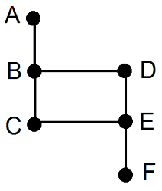

1. Draw a sub-graph of the graph on the right.

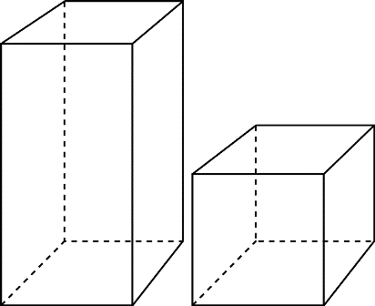

1. Represent the following three-dimensional prism as a planar graph.

**Question 3 [10 marks: 1, 2, 3, 4]**

The graph on the right shows the location of a warehouse, *W*. This warehouse supplies timber to six factories *A, B, C, D, E* and *F.* The number along the edges indicates the length (in kilometres) of the connecting roads.

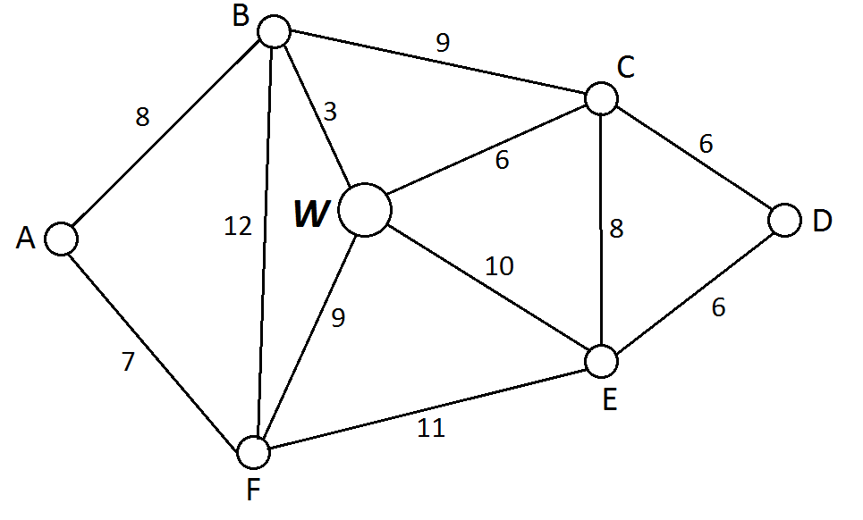

1. What is the degree of vertex *W*? ____________
2. A delivery van is at vertex *A*. It must make a delivery to vertex *E* before returning to the warehouse. Determine the minimum distance travelled on this journey.
3. A salesman wants to leave the warehouse and visit every factory once before returning to the warehouse.
   1. What is the mathematical term used to describe the route he is going to take?
   2. Define a route that he could take.
4. The company wishes to lease an office which is adjacent to two of the factories.
   1. Draw one possible location for the company on the graph, including one road to each of the adjacent factories.
   2. What impact will these two extra roads have on the degree of the vertices?

* 1. The owner wishes to check for any competitors along the route. Will the owner have to complete an open or closed trail if she wants to travel along every edge only once?

**Question 4 [6 marks: 2, 2, 2]**

In a netball competition there are four teams participating.

a) If every team needs to play each other exactly once, how many games are required for the season?

b) Draw the graph showing how each team can play each other, what type of graph would this be?

c) If two more teams join the competition how many more games are required to be played in order for each team to still play each other exactly once?

|  |  |
| --- | --- |
|  | Student Name _______________________    **Eastern Goldfields College**  Mathematics Applications U3&4 2018  Test 3 1– Calculator Assumed Section |
| **Working Time: 25 minutes** | **Total Marks: 20 marks** |

**Question 1 [6 marks: 3, 2, 1]**

Consider the following undirected graph.



1. Construct the adjacency matrix, *M*, for the above digraph.

*M = $\begin{matrix} & A & B & C & D & E \\ A & & & & & \\ B & & & & & \\ C & & & & & \\ D & & & & & \\ E & & & & & \end{matrix}$*

1. Calculate *M*2and explain the significance of the zero elements in this matrix.

*M2=*

1. Identify a practical situation that could be represented by this network.

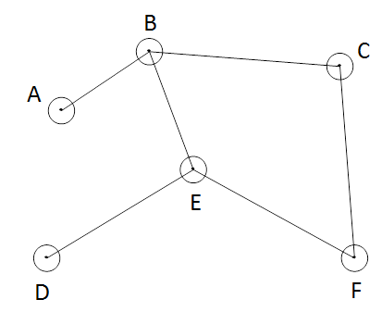**Question 2 [3 marks: 1, 2]**

A treasure hunt is being organised and a graph showing where prizes are hidden is shown right.

1. Show a semi-Hamiltonian path which you could walk in order to collect all the prizes.

b) Is it possible to create an Eulerian circuit for the treasure hunt by adding exactly one edge? If so, what is the pathway, if not, explain why?

**C**

**Question 3 [11 marks – 4, 1, 6]**

The following network shows some of the corridors running through a large hospital. Most of the thoroughfare through this hospital is from A to E.

The hospital receives some funding to upgrade some of the finishings in the corridors. In order to maximise their budget they decided to upgrade the shortest path from A to E as these would be the most used corridors. The cost of upgrading is $95/metre.

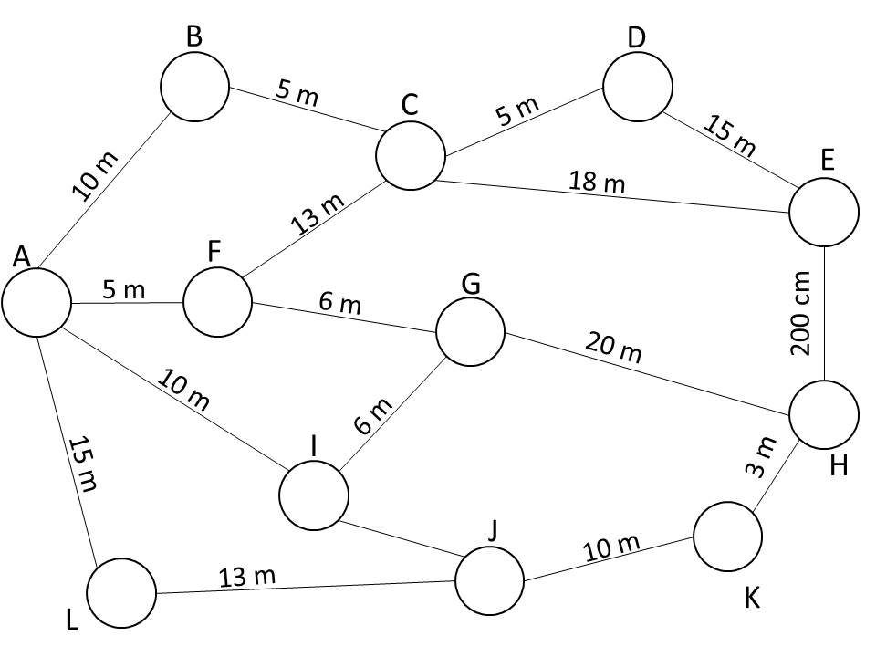

7 m

1. What is the shortest distance from A to E and what is this pathway?

1. What is the cost of upgrading the shortest path from A to E?

Upon further discussions it appears that not all the corridors require the same amount of work to upgrade and therefore the costs of upgrading each corridor are not equal. The following table shows the multiplication factor in the costs of upgrading each corridor relative to the lengths.

|  |  |  |  |  |  |  |  |  |  |  |  |  |
| --- | --- | --- | --- | --- | --- | --- | --- | --- | --- | --- | --- | --- |
|  | A | B | C | D | E | F | G | H | I | J | K | L |
| A |  | 1 |  |  |  | 1.9 |  |  | 0.3 |  |  | 0.1 |
| B | 1 |  | 1.2 |  |  |  |  |  |  |  |  |  |
| C |  | 1.2 |  | 0.9 | 1 | 0.2 |  |  |  |  |  |  |
| D |  |  | 0.9 |  | 1.1 |  |  |  |  |  |  |  |
| E |  |  | 1 | 1.1 |  |  |  | 1 |  |  |  |  |
| F | 1.9 |  | 0.2 |  |  |  | 1.6 |  |  |  |  |  |
| G |  |  |  |  |  | 1.6 |  | 2 | 0.5 |  |  |  |
| H |  |  |  |  | 1 |  | 2 |  |  |  | 0.2 |  |
| I | 0.3 |  |  |  |  |  | 0.5 |  |  | 0.3 |  |  |
| J |  |  |  |  |  |  |  |  | 0.3 |  | 0.6 | 0.1 |
| K |  |  |  |  |  |  |  | 0.2 |  | 0.6 |  |  |
| L | 0.1 |  |  |  |  |  |  |  |  | 0.1 |  |  |

1. Taking into account the multiplication factors, which path from A to E should the hospital upgrade in order to minimise costs? Clearly state this path and the total cost of upgrading it. Use the blank network below to assist with your answer.

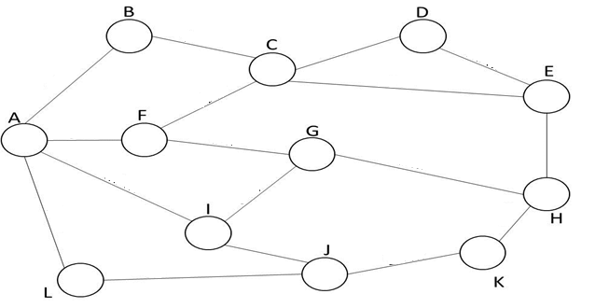

**END OF TEST**